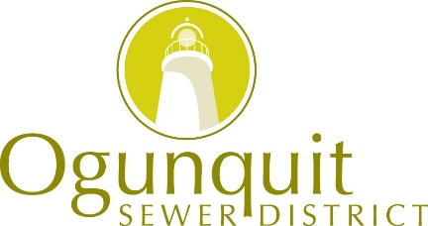 February 2023

WHAT’S HAPPENING IN SEWER?

We at the Ogunquit Sewer District hope that you had a great 2022! We welcome you to read through this newsletter to get caught up with what OSD is doing!

For more information on billing, outside meters, impact fees etc. please call the office, or go to our website for a full version of this newsletter. www.ogunquitsewerdistrict.org.

Another announcement! Debbie (the Office Manager) is retiring! OSD is pleased to announce that we have hired Debbie’s replacement! Please join us in welcoming Preston Bowden! Debbie will be phasing out over the next year.

***LOWERING YOUR SEWER BILLS***
Here are some tips on ways you can save
money on your sewer (and water) bills!

- Is it really worth buying a meter for outside watering? Absolutely! When you meter outside water, we won’t bill you for water that doesn’t go down into the sewer system. BIG savings on your sewer bill!!!

- Why should I check the meter during the summer? We only give credit for what actually gets metered. If your meter breaks, you could end up with a sewer bill that is hundreds or even thousands of dollars more than normal! We recommend checking the meter every few weeks, just to be on the safe side!!!

- A leaking toilet can’t affect my bill that much! Unfortunately, we have a several customers each year with very high sewer bills from leaking toilets or fixtures. These should be taken care of right away! A sewer bill of $325.00 could end up at $1,200.00 or more!

- WAYS TO SAVE MONEY…In short… Inspect fixtures for leaks or drips. Replace toilet flapper yearly or buy adjustable flapper. Install low-flow toilets & shower heads. Add aerators to faucets. Take shorter showers (good luck with teenagers!). Use your dishwasher vs. hand washing dishes. Meter your outside watering!!!
- Go to our website for water saving tips!

Q. What do you call a sewer expert?
A. A connois-sewer!

OSD News from 2022

• Charter Revision – The OSD Trustees and staff have completed the Charter revision effective August 8, 2022. The debt limit for borrowing has now been increased from $7,000,000 to $12,000,000, to position OSD to continue with plant & infrastructure upgrades. The majority of the other Charter revisions were to bring OSD into compliance with state statute changes.

• LD 1911, Prohibiting Contamination from PFAS – This PFAS (forever chemicals) related bill passed in the spring of 2022, places a ban on the sale or application in Maine of all wastewater derived sludges and biosolids, including compost derived from sludge. This means all wastewater sludges in the state now have to go to secure landfills. This resulted in a very large increase in sludge disposal costs for all WWTF’s in the state. OSD has been working on ways to lower the cost of our sludge disposal by updating the belt press to produce a dryer (lighter) sludge and by exploring various options, in coordination with other treatment plants to possibly replace the belt press in the future. The DEP additionally started a monthly testing protocol on our final effluent to determine any impacts to the water quality and human health of 28 individual PFAS compounds.

• Sea Level Rise Adaptation Plan – OSD continues to update our infrastructure to prepare for sea level rise, climate change and extreme weather events. With the help of a $2.85 million dollar grant from a Maine infrastructure adaptation fund, OSD will be able to protect the WWTF by extending the sea wall around the facility, relocate & elevate electrical controls and the generator at station 4 (Perkins Cove) and relocate electrical gear at station 3 (Lighthouse) and station 6 (Main Beach).

• Future Planning for OSD – While long term planning may address potential relocation of the current facility, maintaining and ensuring optimal performance and reliability at the current sewer plant requires ongoing upgrades to equipment. Following the recently completed renovations, OSD is working on plans to implement the next phases of improvements outlined by consulting engineers at Wright-Pierce. The full report with recommendations can be found on our website. In addition, environmental concerns dictate that our industry test and mitigate the effects of an increasing number of contaminants that threaten our ecosystem, which is particularly vulnerable on Maine’s southern coast. OSD has been approved for a $6.47 million-dollar clean water state revolving fund (CWSRF) loan.

OSD is now working on plans to implement the next phases of improvements, as outlined by consulting engineers at Wright-Pierce. The full report can be found on our website.

Did You Know?
Treated sewage gets discharged into the ocean:

Once the sewage that comes into our plant gets treated, the liquid gets discharged half a mile out into the ocean. The remaining solids are picked up by Casella Organics for disposal into a secure landfill.

We have an emergency line:

For all sewer emergencies you can call (207) 641-5508. The plant has an operator on call 24/7. This includes if you have sewer backing up into your home. Please do not call this number for billing questions or other non-emergency related reasons. For non-emergencies, please see our office hours at the end of this newsletter.

Storm drains are not a part of OSD:

Storm drains are the drains in the street that have holes or grates in them to accept surface water. If you see a plugged or backed-up storm drain, please call the Public Works Dept. OSD does not operate or maintain storm drains.

However, if you drive over a loose manhole cover and notice a rattling sound, feel free to call the office and let us know or leave a message with the location of the manhole cover. We will address this during normal business hours.

Storm drains all flow to our rivers and the ocean
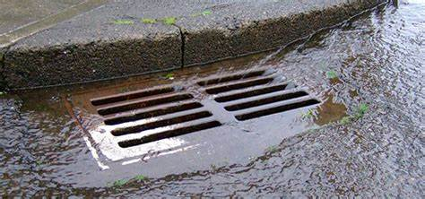

Manholes all flow to wastewater facility for treatment
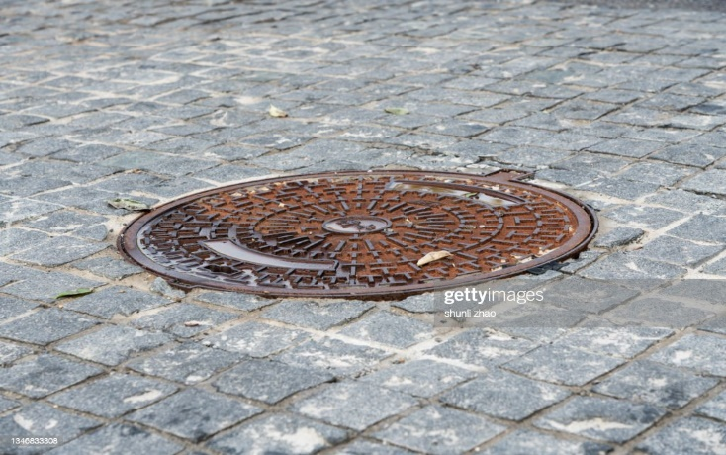

Sewer, Water & the Town of Ogunquit

We would like to remind everyone that Ogunquit Sewer District, the Town of Ogunquit & KKWWD (Kennebunk, Kennebunkport, Wells Water District) are three, completely separate entities!

To Flush or Not to Flush! To help keep the sewer systems functioning properly, the following products should not be flushed:
    - Flushable wipes (are not flushable), baby wipes or cleaning wipes (responsible for 93% of blockages)
    - Paper towels
    - Tissues
    - Dental floss
    - Tampons and sanitary products
    - Cotton balls and swabs
    - Cat litter
    - Prescription drugs & over-the-counter medicines
    - Cigarette butts
Unlike toilet paper, these products do not break down and are likely to clog the plumbing in your house, the lateral sewer line from your house to the sewer main, your septic system, as well as the public sewer lines & pumps.
When these products make their way into the public sewer system they clump together, causing very large obstructions in the sewer lines. They get tangled in pump stations
requiring repair of equipment and causing backups and discharges of raw sewage into basements of homes and businesses, and into waters of the state.
~ ~ ~ ~ ~ ~ ~ ~ ~ ~ ~ ~ ~ ~ ~ ~ ~ ~ ~ ~ ~ ~ ~ ~ ~ ~ ~
GIS Map to locate sewer lines & manholes: We have our very own GIS map on our website, showing sewer mains, lines & manholes! Very useful information! Click on “Sewer System Map” at the top right corner of our website.

Please keep in mind that the sewer line locations shown on the map are for representation purposes only. Please call to verify exact locations/dimensions. Remember to call Dig Safe, KKWWD & OSD to mark out services before any below ground excavation.

Office Hours:
Our regular office hours are: Monday – Friday, 8 am – 2 pm. Please call before visiting, as we have only one staff member in the office, who may be out or unavailable at that time.

For assistance or questions, please call Preston at
207-646-2028 or email: preston@ogunquitsewerdistrict.org.

Be well and best wishes for a great year! Thank you!

Board of Trustees

William Sawyer ~ Helen Horn ~ Priscilla Botsford

